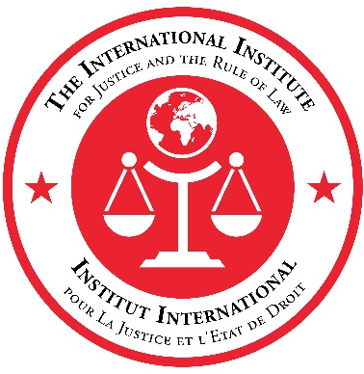

IIJ VACANCY
PROGRAMME ASSISTANT

ABOUT THE IIJ

The International Institute for Justice and the Rule of Law (IIJ) is located in Malta with a mission to deliver innovative and sustainable capacity-building through the implementation of counter-terrorism-related, rule of law-based good practices developed by the Global Counterterrorism Forum (GCTF) and other international and regional fora.

Since its inauguration in 2014, the IIJ has trained more than 7000 criminal justice practitioners through its interactive capacity-building workshops – in Malta and abroad – that enhance the competencies of parliamentarians, judges, prosecutors, police, prison and other criminal justice practitioners to address terrorism and related transnational criminal activities within a rule of law framework. The IIJ delivers capacity-building training tailored to the needs of the regions it serves, including North, West and East Africa; the Middle East; and select engagement in the Balkans, and Central, South and Southeast Asia. For more information on the IIJ, please visit the IIJ’s website www.theiij.org

POSITION

Under the overall guidance of the IIJ Executive Secretary, and the direct supervision of the Director of the Administration and Outreach, the Programme Assistant will be an integral part of a dynamic and multi-national team. The IIJ is a highly collaborative environment, and the Programme Assistant will work in close collaboration with the IIJ’s dedicated Administrative Unit, on the preparatory and delivery phases of IIJ courses and programmes.

Duties and Responsibilities

Programme Management and Administrative Support to the Programmatic Unit:

- Support the implementation of the various programme activities within the scope of the IIJ’s mission.
- Provide the necessary assistance to support the organisation, logistics and implementation of course curricula and other capacity-building activities.
- Provide administrative support to the Programmatic Unit in the organisation of events, meetings and workshops, etc.
- Prepare travel plans and organise travel dates for participants to IIJ events, and for IIJ staff as required. Prepare travel requests to be sent to the travel agents to issue air tickets.
- Provide programme and administrative support to the IIJ in the preparation of various programme documents, such as work plans, budgets, reports and proposals on programme implementation arrangements.
- Under the guidance of the Director, assemble briefing materials and prepare PowerPoint and other presentations for the Programmatic Unit.
- Identify sources and gather and compile data and information for the preparation of documents, guidelines, and other material as required.
- Notetaking in meetings and drafting written reports.
- Assist the team in monitoring and implementation programme activities, including analysis of achieved outcomes, financial monitoring and reporting.
- Maintain an organised electronic and hardcopy filing systems in accordance with internal procedures, which includes the preparation and recording of all documentation and control plans used for the monitoring of programme implementation.
- Drafting contributions to programme-related reports and correspondence
- Maintaining up-to-date work files for the IIJ Programmatic Unit.
- Liaising with participants at each stage of the course cycle.
- Translation of documents as required.
- Performing other administrative duties to support both the IIJ’s operational frameworks as required.

Criteria & Qualifications

The mandatory requirements for this role are as follows:

Education
Completion of secondary education is required, supplemented by formal training in secretarial administration support. University degree (or equivalent) in Business or Public Administration or related field is an asset.
Work Experience
A minimum of three years of relevant experience in secretarial or administrative support functions.

Skills
- Fluent in Arabic and French language.
- Professional fluency in English with excellent oral and written communication skills.
- Drafting and reporting skills.
- Computer literacy, including Microsoft Office.
- Demonstrated awareness of multicultural dynamics and the ability to work in a team, while establishing collaborative working relationships with persons from diverse cultural backgrounds.
- Current authorization to work in Malta.

Deadline for Applications

All interested applicants meeting the qualifications and personal specifications listed above are invited to submit a cover letter and resume/CV to the IIJ Executive Secretariat via HR@theiij.org clearly stating “PA01_2022” in the subject line. The vacancy shall remain open until filled.

