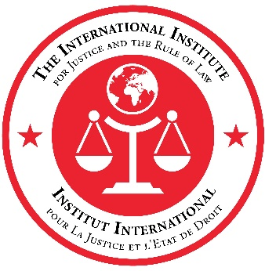

United Nations General Assembly (UNGA 76) Side Event

Battlefield Evidence and
Criminal Justice Approaches to Counter-Terrorism

Wednesday 29 September 2021
08:00 – 09:30 Eastern Standard Time (EST)

AGENDA

08:00 – 08:10 Opening Remarks

- Mr. Thomas Wuchte, Executive Secretary, International Institute for Justice and the Rule of Law (IIJ)
- Mr. Christopher Landberg, Acting Principal Deputy Coordinator of Counterterrorism, Department of State, Government of the United States of America

08:10 – 08:50 Session 1: Battlefield Evidence and Counter-Terrorism - Importance for International Security
Presenters will discuss the continued importance of battlefield evidence and the integral role that effective, rule of law–based counter-terrorism plays in international peace and security. A brief Q&A period moderated by IIJ Programme Manager Winthrop Wells to follow.

- Mr. Mark Lesko, Acting Assistant Attorney General for National Security Division, Department of Justice, Government of the United States of America
- Dr. David Scharia, Director and Chief of Branch, United Nations Security Council Counter-Terrorism Committee Executive Directorate (UN CTED)
- Dr. Seyda Emek, Advisor to the Counter-Terrorism Coordinator, European Union

08:50 – 09:30 Session 2: Collection, Sharing and Use of Battlefield Evidence -- Progress and Priorities
Presenters will discuss recent advances in the collection, exploitation and international sharing of battlefield evidence, and its use in court for prosecution of individuals who have committed terrorist offences or other crimes, as well as identify further improvements needed to address pressing challenges. A brief Q&A period to follow.

- Mr. Masood Karimipour, Chief of the Terrorism Prevention Branch (TPB), United Nations Office on Drugs and Crime (UNODC)
- Ms. Claudia Gorf, Senior Public Prosecutor for the Federal Court of Justice, Government of Germany
- Mr. Afrim Shefkiu, State Prosecutor in the Special Prosecution Office and Head of Counter Terrorism Department for the Ministry of Justice, Government of Kosovo
- Mr. Sahibou Alzouma Maïga, General Prosecutor for the Appeals Court of Niamey, Ministry of Justice, Government of Niger

